ECG Biometric Authentication System
Project Report

Team Members
Rana Nasser | Esraa Taha
Gihad Mahmoud | Menna Mahrous
Mona Khaled

1. Data Preparation & Preprocessing

1.1 Dataset
The dataset used is the ECG-ID Database, which consists of ECG recordings collected from 5 subjects (Person_1 through Person_5). Each person has multiple recordings stored in WFDB format (.dat/.hea). The signal was sampled at 500 Hz and recorded from Lead I.

1.2 Training and Testing Split
For each subject, the available recordings were divided as follows:
- Training set: first 5 recordings per subject.
- Testing set: last 2 recordings per subject (or all remaining if fewer than 7 exist).
Subject | Total Recordings | Training Records | Testing Records
Person 1 | 20 recordings | First 5 | Last 2
Person 2 | 20 recordings | First 5 | Last 2
Person 3 | 20 recordings | First 5 | Last 2
Person 4 | 20 recordings | First 5 | Last 2
Person 5 | 20 recordings | First 5 | Last 2
Table 1: Training and testing split per subject.

1.3 Preprocessing Pipeline
Each raw ECG signal passes through a six-step preprocessing pipeline before features are extracted. The steps are summarised below; corresponding screenshots/plots can be inserted in the marked figure placeholders.

Step 1 — Raw Signal Acquisition
The raw ECG signal is read directly from the WFDB record. It contains unfiltered cardiac electrical activity, including baseline wander, high-frequency noise, and power-line interference.

Step 2 — Bandpass Filtering
A 4th-order Butterworth bandpass filter with a 1–40 Hz passband is applied to remove baseline wander and high-frequency noise while preserving ECG morphology (P, QRS, T). The filter is applied forward and backward (zero-phase) to avoid phase distortion.

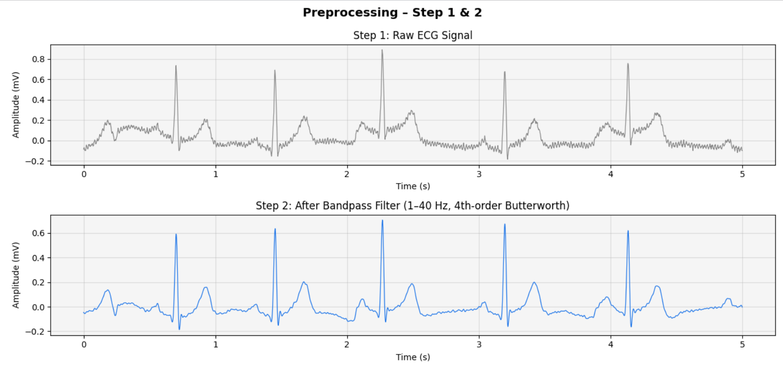Step 3 — Differentiation
The filtered signal is differentiated to highlight rapid amplitude changes, particularly the steep slopes of the QRS complex. This step emphasises R-peak transitions.

Step 4 — Squaring, Integration & Adaptive Thresholding
The differentiated signal is squared to make all values positive and amplify large deflections. A moving-average window (0.15 s) generates a smooth energy envelope. An adaptive threshold (mean + 1.5×std) is then computed to separate true QRS complexes from noise and T-waves.

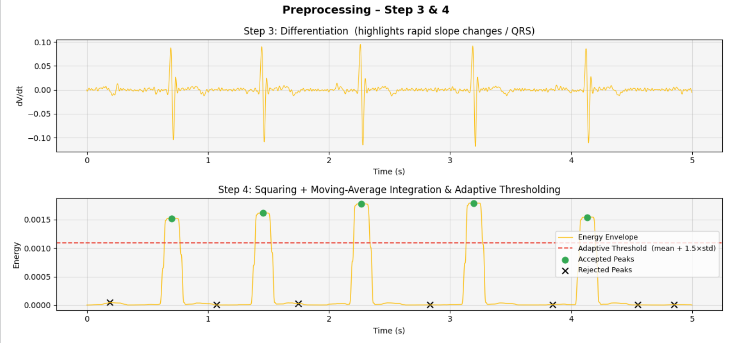Step 5 — R-Peak Detection (Pan–Tompkins)
Candidate peaks in the integrated envelope are detected using a peak-finding routine with a minimum distance of 0.3 s (to avoid detecting more than one beat at high heart rates). Each candidate is refined by searching the filtered ECG within ±25 ms to locate the exact local maximum, yielding precise R-peak indices.

Step 6 — Heartbeat Segmentation
Each R-peak is used to extract a fixed-length heartbeat segment: 200 ms before the R-peak and 400 ms after it (300 samples at 500 Hz). Beats that would exceed the signal boundaries are discarded. 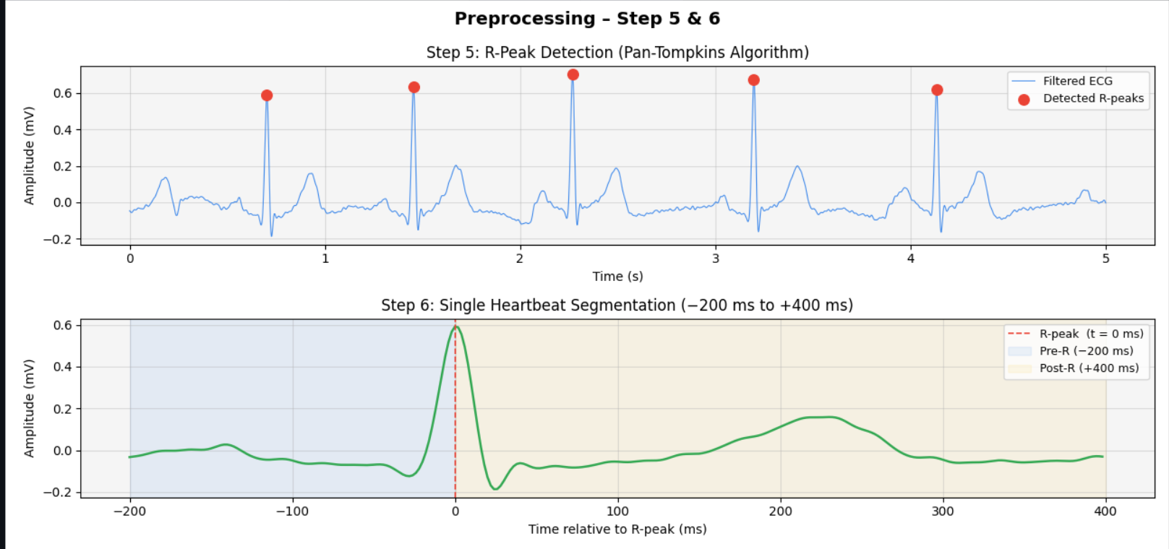

2. Feature Extraction

2.1 Fiducial Point Features
For each segmented heartbeat, five characteristic fiducial points are located: P-wave peak, Q-point (QRS onset), R-peak, S-point (QRS offset), and T-wave peak. These points are used to derive three time-interval features:
- PR Interval — time from P-wave peak to R-peak.
- QT Interval — time from Q-point to T-wave peak.
- QRS Duration — time from Q-point to S-point.

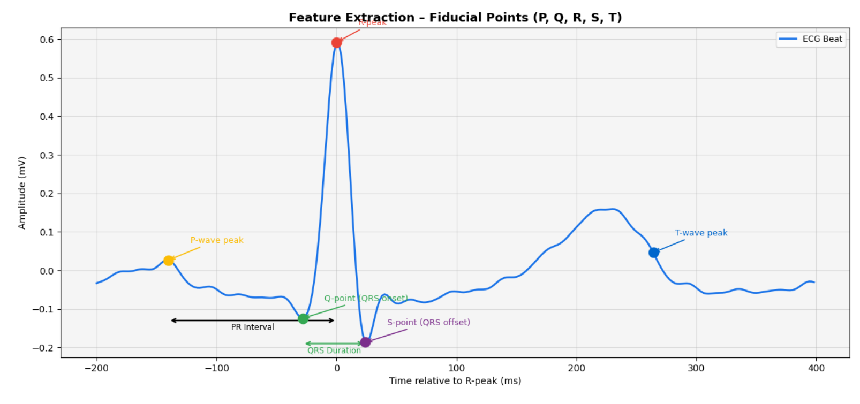2.2 Wavelet Decomposition Features
Each heartbeat is decomposed using the Discrete Wavelet Transform (DWT) with a Daubechies (db4) mother wavelet at 4 decomposition levels. The resulting sub-bands capture frequency-localised morphology information.
Sub-band | Frequency Range | Used? | Features | Description
cA4 | 0–15 Hz | Yes | Mean, Std, Energy | Approximation coefficients
cD4 | 15–30 Hz | Yes | Mean, Std, Energy | Detail level 4 (QRS band)
cD3 | 30–60 Hz | Yes | Mean, Std, Energy | Detail level 3 (QRS band)
cD2 | 60–125 Hz | No | — | High-frequency noise
cD1 | 125–250 Hz | No | — | Very high-frequency noise
Table 2: Wavelet sub-bands and their usage (highlighted rows are selected).
Three statistical descriptors are extracted from each selected sub-band (Mean, Standard Deviation, and Energy), yielding 9 wavelet features per heartbeat. Combined with the 3 fiducial interval features, the final feature vector has 12 dimensions per beat.
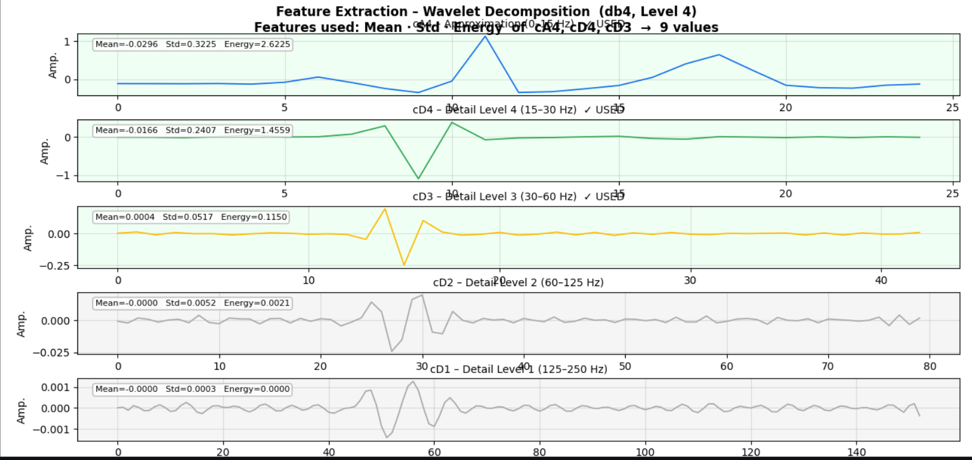
Table 3: Feature vector composition (12 features per beat).

3. Classifiers & Parameters
Three supervised classifiers were evaluated. Each classifier was tested with three parameter configurations and three wavelet choices (db1, db2, db4), yielding 27 experimental runs. Feature vectors were standardised (zero mean, unit variance) before training and testing. Classification of a full record is performed by majority vote across extracted beats; a subject is accepted only if more than 80% of beats agree on the same label.

3.1 Support Vector Machine (SVM)
SVM finds the maximum-margin decision boundary separating classes in a high-dimensional feature space. Probability estimation can be enabled to support soft voting.
# | Kernel | C | Gamma | Rationale
1 | RBF | 1 | scale | Baseline RBF
2 | RBF | 10 | scale | Higher regularisation
3 | Linear | 1 | — | Linear boundary
Table 4: SVM parameter configurations.

3.2 Random Forest (RF)
Random Forest is an ensemble of decision trees trained on bootstrap samples. Predictions are aggregated by majority vote across trees; a fixed random seed can be used for reproducibility.
# | n_estimators | max_depth | Rationale
1 | 50 | 5 | Small, shallow — fast baseline
2 | 100 | 10 | Medium — balanced complexity
3 | 200 | None | Large, deep — maximum expressiveness
Table 5: Random Forest parameter configurations.

3.3 K-Nearest Neighbours (KNN)
KNN classifies a sample by finding the k closest training samples (typically using Euclidean distance) and assigning the majority class. It requires no explicit training phase, but prediction cost increases with dataset size.
# | k (n_neighbors) | Weights | Rationale
1 | 3 | uniform | Very local boundary
2 | 5 | uniform | Standard default
3 | 7 | uniform | Smoother decision boundary
Table 6: KNN parameter configurations.

4. Classification Results

4.1 All Results — Sorted by Accuracy
The table/figure below lists accuracy for all 27 combinations (3 classifiers × 3 wavelets × 3 parameter sets), sorted by descending accuracy. Suggested highlighting: green ≥ 95%, yellow ≥ 90%, red < 90%.
[Insert Figure 6 here]
Full results table for all 27 runs (sorted by accuracy). 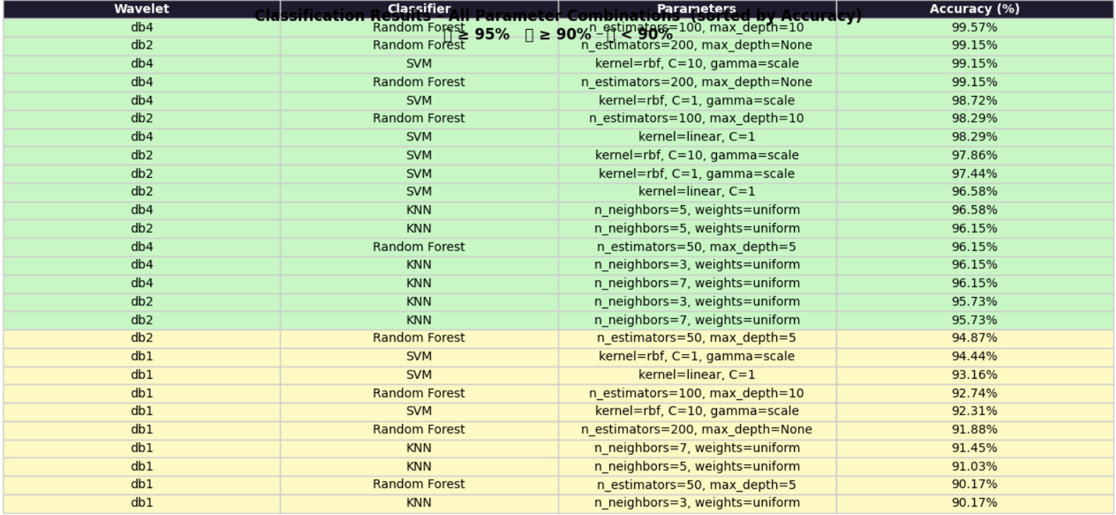

4.2 Best Result per Classifier
The table below summarises the best-performing configuration for each classifier across all wavelets.
Classifier | Best Wavelet | Best Accuracy (%)
SVM | db4 | 99.15%
Random Forest | db4 | 99.57%
KNN | db4 | 96.58%
Table 7: Best accuracy per classifier across all wavelets.

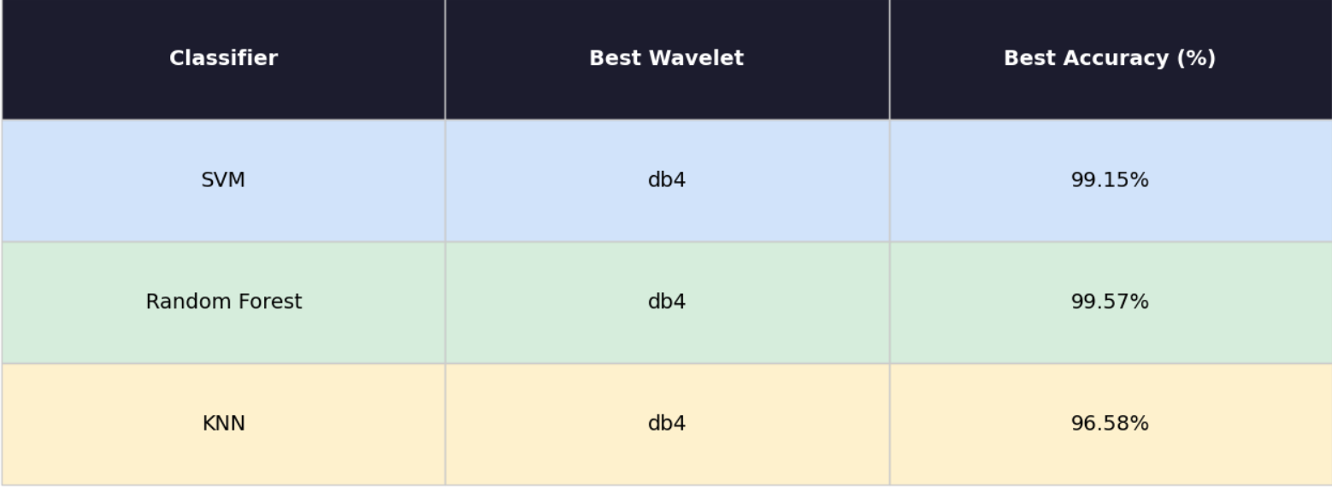4.3 Accuracy Comparison Chart
The chart below compares the three classifiers across the three wavelets. In our experiments, db4 consistently produced the best performance, and Random Forest with db4 achieved the highest overall accuracy (99.57%).

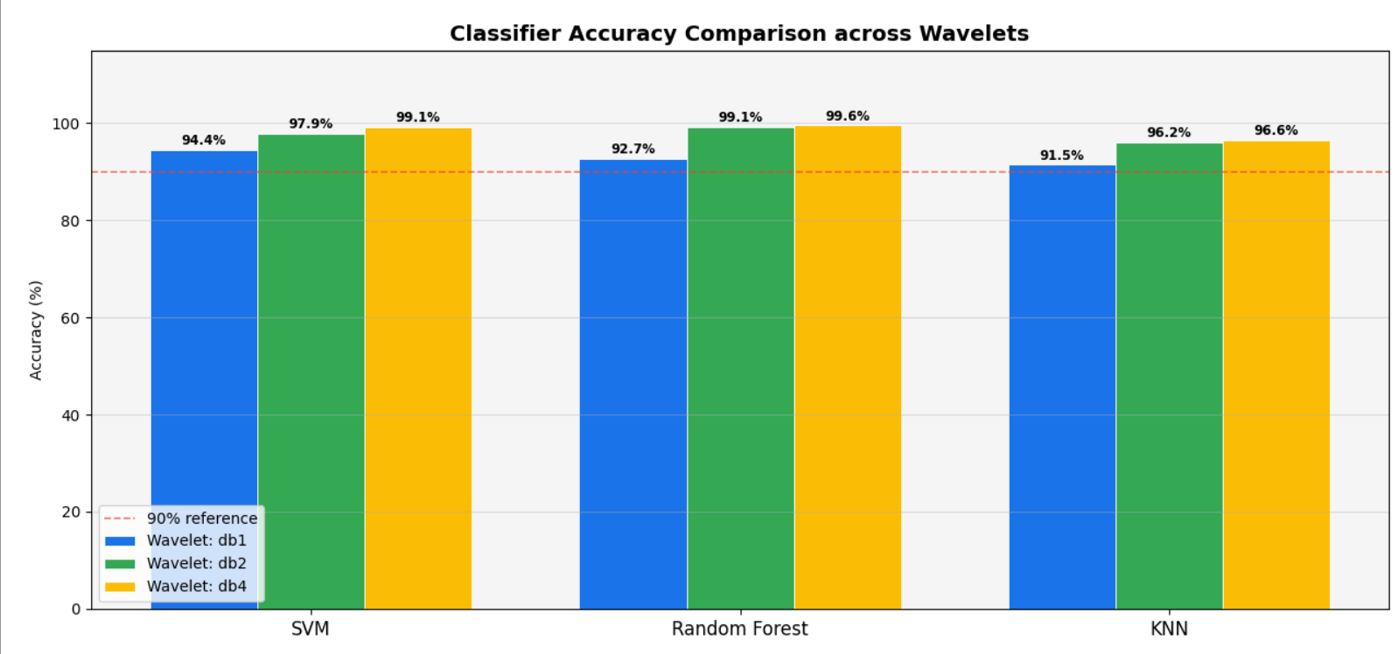4.4 Confusion Matrix — Best Model
The confusion matrix below shows per-subject performance of the best model (Random Forest, db4, n_estimators=100, max_depth=10). In the reported run, the model achieved 99.57% accuracy, with only one misclassification out of 233 test beats.

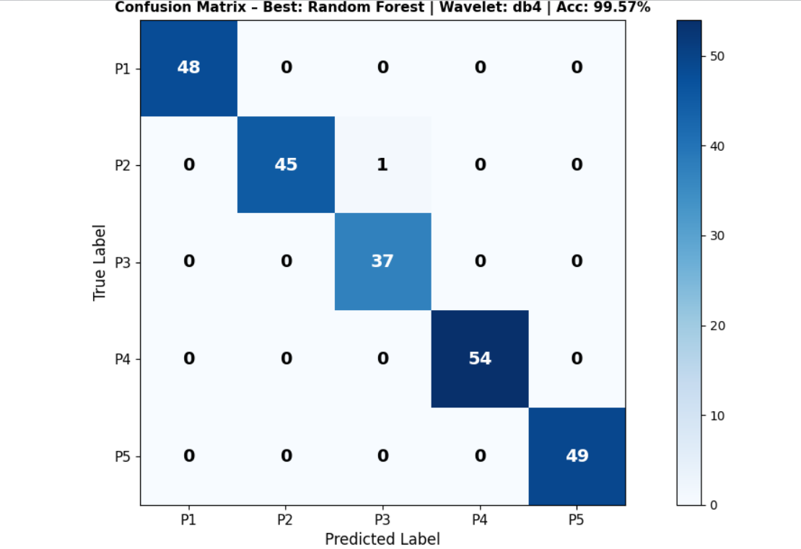5. Running Interface Screenshots
The system provides a graphical user interface (GUI) built with Python Tkinter, featuring three main areas: Authentication, Preprocessing visualisation, and Classifier Results. The interface allows a user to load a WFDB ECG record and receive an identification result with a confidence score.

5.1 Authentication Tab
The Authentication tab is the primary screen. It allows the user to load an ECG record, displays the active pipeline configuration, and shows the identification result with a confidence indicator. A subject photo panel can be populated when a match is found.

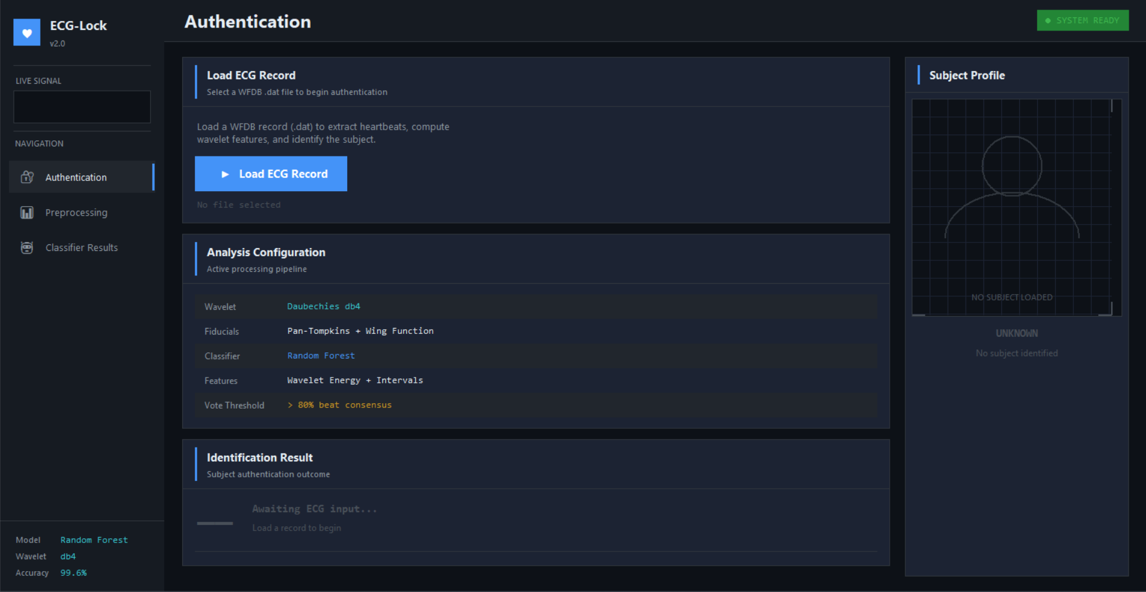5.2 Preprocessing Tab
The Preprocessing tab contains sub-tabs showing each stage of the ECG processing pipeline with live plots rendered inside the application. These include:
- Step 1 & 2 — Raw signal vs. bandpass-filtered signal.
- Step 3 & 4 — Differentiation and adaptive thresholding.
- Step 5 & 6 — R-peak detection and heartbeat segmentation.
- Fiducial Points — P, Q, R, S, T annotation on a beat.
- Wavelet (db4) — decomposition levels with statistics.

5.3 Classifier Results Tab
The Classifier Results tab presents sub-tabs for model evaluation and comparison:
- All Results — sortable table of all 27 accuracy values.
- Best per Classifier — summary of the top configuration per classifier.
- Accuracy Chart — grouped bar chart across wavelets.
- Confusion Matrix — heatmap for the best model.

System Summary
Best Model: Random Forest (n_estimators=100, max_depth=10) | Wavelet: db4 | Accuracy: 99.57%
Feature Vector: 12 features/beat (9 wavelet + 3 fiducial) | Vote Threshold: > 80% beat consensus

